**CA2 WEB DESIGN PROJECT**

Hi Cormac,

Kindly find below a link to my Mental Health Website and also my video presentation. In addition, scores obtained from the google speed test.

Mental Health Website.

<https://mazetech89.github.io/webdesignmoduleCA2/>

Link to my video presentation.

https://web.microsoftstream.com/video/3b4dd5c8-1496-4ed0-92df-5c9c64e41532

**Google Page speed**

**First**

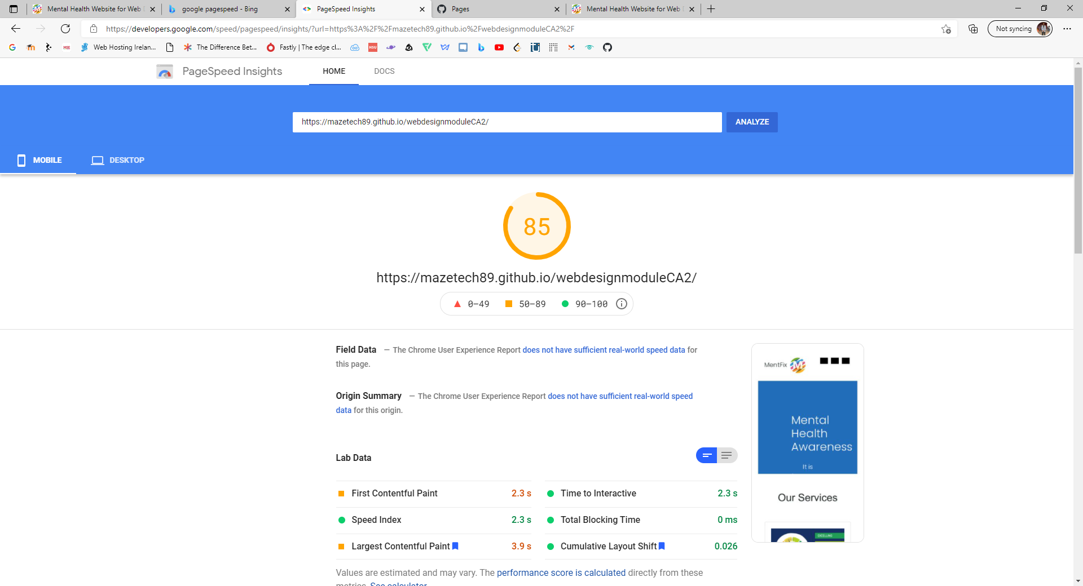

**Second**

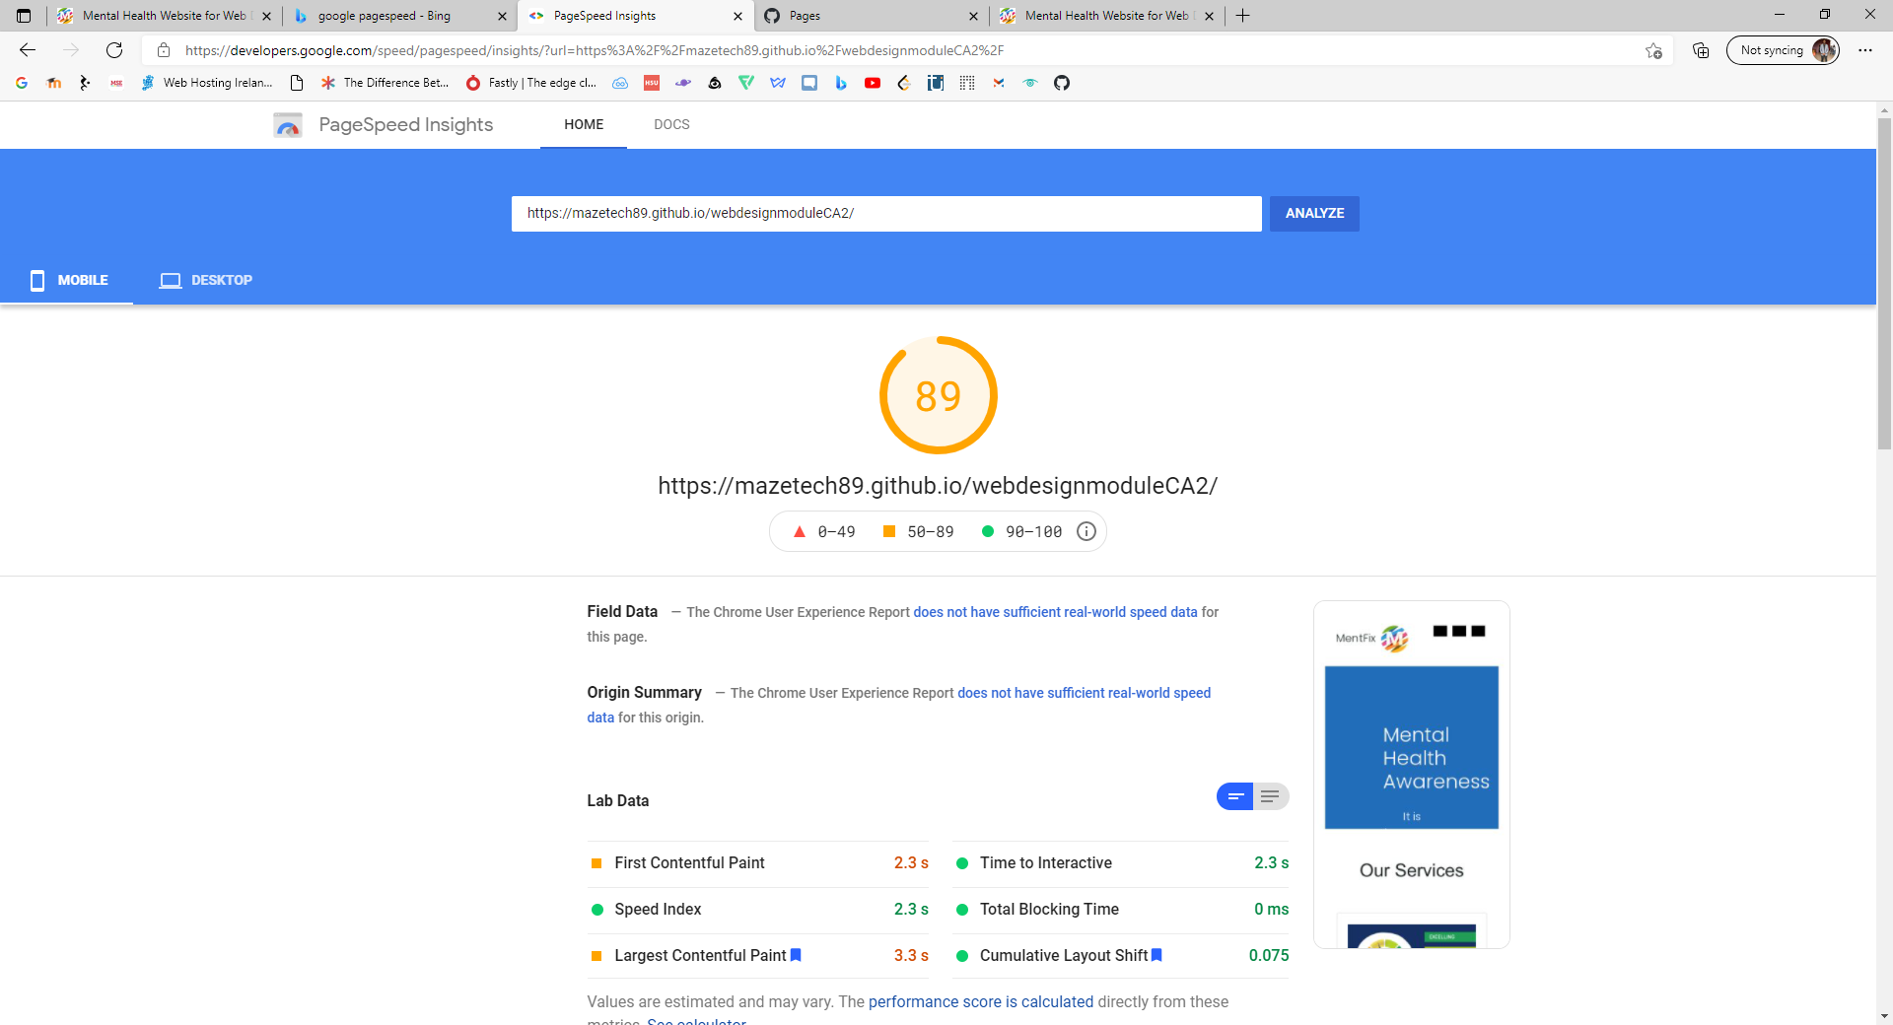

**Final**

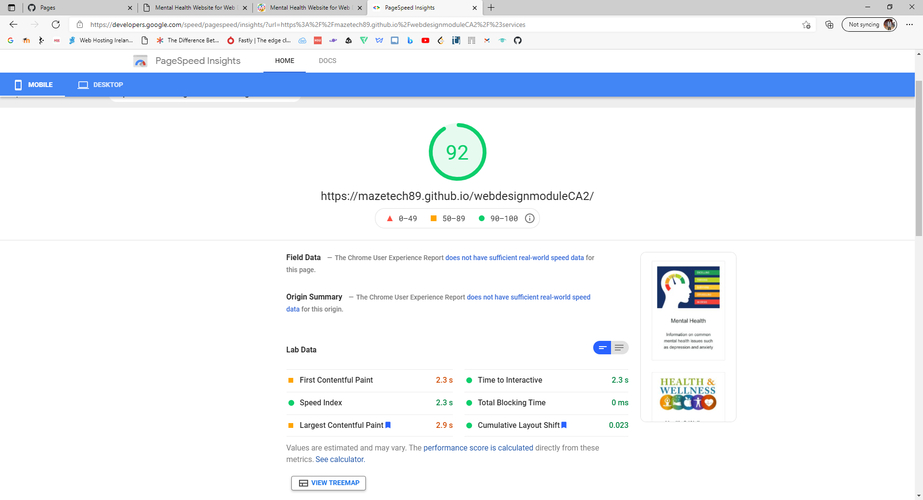

Measures taken to improve speed

* Re-sized all images to be 800px and load faster and consume less cellular data.
* Only used critical JS/CSS inline and deferring all non-critical JS/styles because resources are blocking the first paint of my page.